Call for Nomination: 2026 IDMP Award
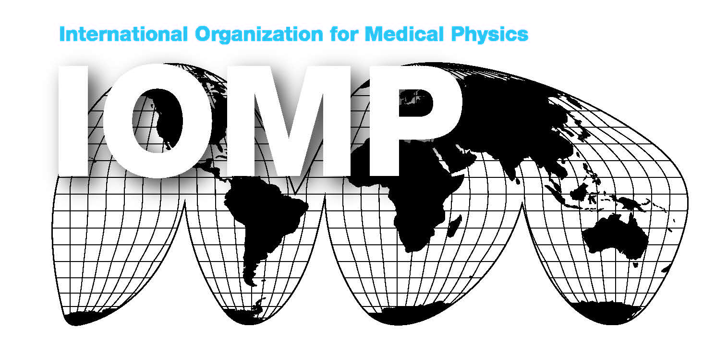
The IOMP is pleased to seek nominations for the IDMP Award. This award recognises excellence in Medical Physics professional service with a particular view of promoting medical physics within their geographic region and highlighting the contributions medical physicists make to patient care. The 2026 IDMP Award is given on the occasion of the celebration of the International Day of Medical Physics (IDMP) and will be announced on November 7, 2026.
The IDMP Award consists of an IOMP certificate, and additionally, a short biography of the awardee will be published in the IOMP Bulletin, e-Medical Physics World (eMPW).
Criteria for selection:
- The recipient of the award should be a professional medical physicist holding a master’s degree or higher, or equivalent, who is an active member of a relevant Medical Physics Society.
- The recipient should have taken an active part in promoting medical physics, nationally and/or internationally.
- The recipient should demonstrate a strong professional contribution within the region that nominates them.
- The recipient should have performed original and/or applied work of high scientific quality or made a significant professional contribution to Medical Physics in the past three years.
- Only deserving candidates will be selected. If no one meets the criteria for a region, no award will be given.
- The nominee shall not be a current member of the IOMP Awards & Honours Committee or Executive Committee.
Nominating Procedure:
- Each National Member Organization (NMO) and Regional Organization (RO) can nominate for this award.
- Nominations to IOMP should be made by the President or Secretary General of the Organization. In exceptional circumstances (e.g., from countries where no NMO exists), individuals can nominate a colleague directly. It is recommended that the nominating person checks with the IOMP AHC prior to submitting such a nomination.
- Self-nomination will only be considered in exceptional circumstances.
- Nominees should be full members of an IOMP NMO.
- The nomination should include the following documents:
- A letter of not more than 1,000 words describing the nominee’s achievements and identifying the specific work or professional contribution to be recognized.
- IOMP award form completed by the candidate and signed by the nominator.
- A curriculum vitae including all publications.
- A brief biographical sketch (500 words).
Nominations must be submitted online via Google form (https://forms.gle/cUhb66wBxJmJgXUx5) by 9 August 2026. All submissions and supporting materials must be provided in PDF format.
Important note: Please label the files using the nominee’s name and according to the format described below.
- A filled/completed nomination form is available from the IOMP website.
(Label the file as 01_LastName_FirstName_nomination form).
- A letter of not more than 1,000 words describing the nominee’s achievements and identifying the specific work or professional contribution to be recognized.
(Label the file as 02_LastName_FirstName_achievement).
- A curriculum vitae including all publications.
(Label the file as 03_LastName_FirstName_CV).
- A brief biographical sketch (500 words).
(Label the file as 04_LastName_FirstName_biography).
One medical physicist per IOMP Regional Organization (i.e. EFOMP, AFOMP, SEAFOMP, MEFOMP, ALFIM, FAMPO and North America) will be selected by the AHC to receive the award.
The winners will be announced on November 7, 2026.

