 International Organisation for Medical Physics
www.iomp.org
Fairmount House, 230 Tadcaster Road, York YO24 1ES United Kingdom
Telephone +44 (0) 1904 610821 Email: sally@ipem.ac.uk

Advertising and Webmaster: Dr Magdalena Stoeva, SG IOMP
Email: ms_stoeva@yahoo.com Telephone: +359 889 711 715

Advertising Rates IOMP Newsletter

Banner
Description: Newsletter banner with a link.
Banner size: 220 x 100 px
Location: inside the IOMP quick links section, see below

Subscription plans:
Plan | Number of issues | Cost, EUR
Single | 1 | 500
Half year | 3 | 1200
Annual | 6 | 2000
Custom period/frequency | custom | TBD

Location of banner
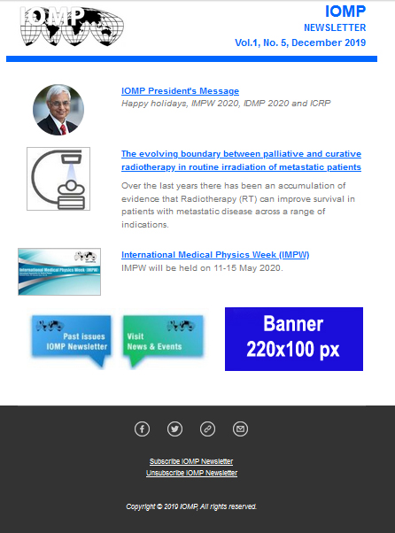

Available discounts:
50% discount is available for IOMP corporate members in good standing.
50% discount with plans 2+ years
Agency discount 15%.
Discounts do not combine. Only the highest discount percentage is valid.

Copy: Web-ready copy required. Sizing defined above.
Image file formats - banner: .JPG, .PNG, .GIF

Sponsored article

Description: An IOMP hosted article with up to 1500 words, up to 2 pictures and 5 external links

Subscription plans:
Plan | Number of issues | Cost, EUR
Single | 1 | 500
Annual | 6 | 3000

Available discounts:
50% discount is available for IOMP corporate members in good standing.
50% discount with 1+ years banner advertising plan
Agency discount 15%.
Discounts do not combine. Only the highest discount percentage is valid.

Copy: Web-ready copy required. Sizing defined above.
Image file formats - banner: .JPG, .PNG, .GIF
Text file formats - article: .DOC, .DOCX, .PDF

PURCHASE ORDER

Please complete and email to Dr Magdalena Stoeva: ms_stoeva@yahoo.com (copy to sally@ipem.ac.uk)

Company Name: .............................................................................
Address: ..............................................................................
..............................................................................
Contact name: ........................................... email: .............................................. telephone: ..................................

We wish to order the following advertising in eMPW:

Advert description |  | EUR
 | Total payable EUR

Signed .............................................. Print Name ............................................... Date .......................

Advertising in IOMP website

Payment method:
- Please use the following details for bank transfers and advise us of payment, details shouild be sent to sally@ipem.ac.uk

Account Name: IOMP (Euros)
Bank: Lloyds Bank, Pavement, York, UK
Account No: 86211546
Sort Code: 30-99-99
SWIFT/BIC: LOYDGB21225
IBAN: GB20 LOYD 3099 9986 2115 46

Payment terms: Payment with order preferred otherwise 30 days net from date of invoice
VAT: IOMP is currently not required to register for VAT in the UK

