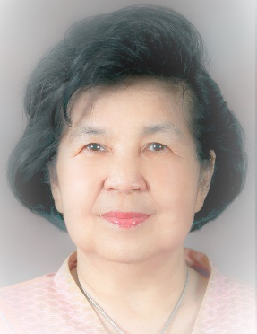

Anchali Krisanachinda, Ph.D., FIOMP, FIUPESM
The Graduate Studies, Faculty of Medicine
Chulalongkorn University
Rama IV Road, Bangkok, Thailand
e-mail: anchali.kris@gmail.com

Anchali Krisanachinda graduated her B.Sc.(Hons) in Physics, M.Sc. (Radiation Physics) from University of London, UK, and Ph.D. (Medical Radiation Physics) from University of Health Science, North Chicago, Ill, USA. She was a Director of Medical Physics Graduate Program, Mahidol University, Bangkok, Thailand. She established Medical Imaging/Medical Physics, graduate programs, M.Sc. and Ph.D. at Chulalongkorn University and became Chairperson of both programs. She established Thai Medical Physicist Society (TMPS) in 2002, started the clinical training of medical physicists in 2007 and obtained Clinically Qualified Medical Physicist, CQMP, in radiation oncology, ROMP in 2009, DRMP in 2012 and NMMP in 2015. Then all 3 branches in medical physics clinical training were started at the same time using AMPLE (Advanced Medical Physics Learning Environment). Medical Physicists in South-East Asia join AMPLE sharing Thai Clinical Supervisors in ROMP and NMMP. The Ministry of Public Health of Thailand approved the medical physics national license in 2022, more than ten years after she requested. Hopefully, in 2023, there will be 300 Thai medical physicist with national license in medical physics. Continue Professional Development in medical physics will be later established. She has received many awards from her Faculty of Medicine and Chulalongkorn University, South-East Asian Federation of Organizations for Medical Physics (SEAFOMP), Asia-Oceania Federation of Organizations of Medical Physics (AFOMP), IOMP and IUPESM.

